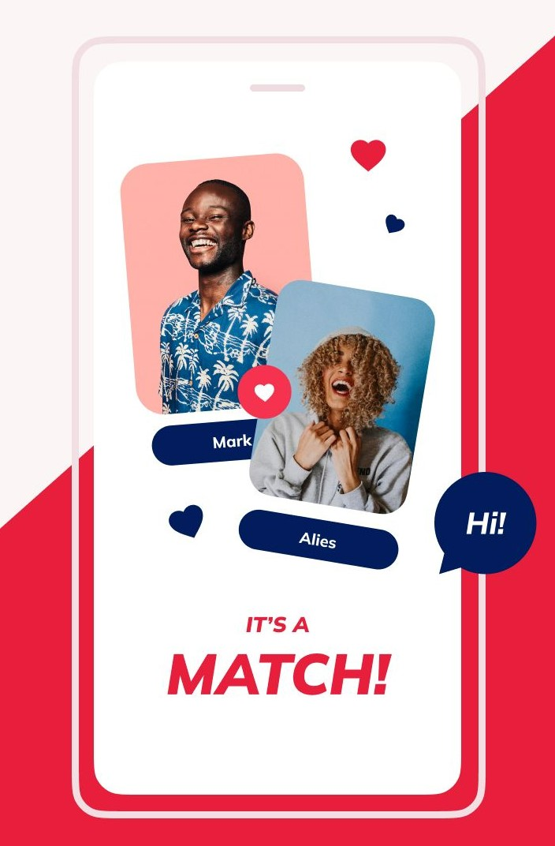

*Dating Application*

Requirement Specification

Introduction

The purpose of this Software Requirement Specification (SRS) is to provide a detailed description of the requirements for the development of a dating application. The dating application aims to connect individuals seeking romantic relationships, providing them with a platform to meet, interact, and potentially form meaningful connections.

1.1 Purpose:

The dating application aims to simplify the process of finding potential partners by leveraging technology and providing users with a user-friendly interface. The application will offer a range of features and functionalities that enhance the overall user experience and increase the chances of successful matches.

1.2 Scope:

The scope of the dating application includes the development of a mobile application compatible with both iOS and Android platforms. The application will incorporate features such as user profiles, matching algorithms, messaging capabilities, search filters, and location-based services to facilitate connections between users.

1.3 Target Audience:

The target audience for the dating application includes individuals aged 18 and above who are interested in forming romantic relationships. The application will cater to users from diverse backgrounds, interests, and geographical locations.

1.4 Key Features:

The key features of the dating application will include:

- User Registration: Users will be able to create an account by providing basic personal information and preferences.

- User Profiles: Users can create detailed profiles including photos, interests, and personal descriptions.

- Matching Algorithm: The application will employ a sophisticated matching algorithm to suggest potential matches based on user preferences, interests, and location.

- Messaging: Users will be able to send and receive messages to initiate conversations and get to know each other better.

- Search Filters: Users can apply various filters such as age, location, interests, and more to refine their search for potential matches.

- Location-Based Services: The application will utilize GPS technology to provide users with nearby match suggestions and facilitate meetups.

- Privacy and Security: The application will prioritize user privacy by implementing robust security measures to protect personal information and ensure a safe online environment.

1.5 Constraints:

The development of the dating application will be subject to certain constraints, including:

- Compatibility: The application must be compatible with a wide range of mobile devices and operating systems.

- Performance: The application should be responsive, fast, and capable of handling a large user base without compromising performance.

- Data Protection: The application must comply with relevant data protection laws and regulations to ensure the security and privacy of user information.

In conclusion, this Software Requirement Specification outlines the objectives, scope, target audience, key features, and constraints for the development of a dating application. By adhering to these requirements, the application aims to provide an intuitive and secure platform for individuals seeking romantic connections.

1. Requirement specification and design
   1. Requirements

|  |  |  |  |  |  |
| --- | --- | --- | --- | --- | --- |
| No. | Name | functional | Non-functional | priority | actor |
| 1 | User registration | yes |  |  |  |
| 2 | login | Yes |  |  |  |
| 3 | logout | Yes |  |  |  |
| 4 | Add friend | Yes |  |  |  |
| 5 | Friend list | Yes |  |  |  |
| 6 | Remove friend | Yes |  |  |  |
| 7 | Block friend | Yes |  |  |  |
| 8 | Best friend | Yes |  |  |  |
| 9 | Profile | Yes |  |  |  |
| 10 | Send message | Yes |  |  |  |
| 11 | Message status | Yes |  |  |  |
| 12 | Delete message | Yes |  |  |  |
| 13 | History | Yes |  |  |  |
| 14 | Group chat | Yes |  |  |  |
| 15 | Feedback |  | yes |  |  |
| 16 | Privacy |  | yes |  |  |
| 17 | Robustness |  | yes |  |  |
| 18 | Performance |  | yes |  |  |
| 19 | Usability |  | yes |  |  |
| 20 | Reliability |  | yes |  |  |
| 21 | Supportability |  | yes |  |  |
| 22 | portability |  | yes |  |  |

High priority functional requirements

1. User registration and authentication: The application should have a feature for users to register with their personal information, such as name, age, gender, and email address. It should also include an authentication process to verify the user's identity.

2. User profile creation: Users should be able to create their profile by adding details about themselves, such as interests, hobbies, and a bio. They should also be able to upload profile pictures.

3. Matching algorithm: The dating app should have a matching algorithm that suggests potential matches based on user preferences, such as age range, location, and interests. The algorithm should consider compatibility factors to provide accurate match suggestions.

4. Search and filter options: Users should be able to search for other users based on specific criteria, such as age, location, or common interests. The app should also allow users to apply filters to narrow down their search results.

5. Messaging and chat functionality: The application should provide a messaging feature that allows users to communicate with their matches. It should support text messaging, as well as features like emojis, media sharing, and voice messages.

6. Privacy and security features: The dating app should prioritize user privacy and security by implementing features like blocking and reporting options for inappropriate behavior or spam. It should also ensure that user data is encrypted and protected from unauthorized access.

7. Geolocation and mapping: The app should integrate geolocation services to enable users to find matches within their proximity. It should display user locations on a map and provide distance information between users.

8. Date planning and scheduling: The application should allow users to plan and schedule dates with their matches. It could include features like calendar integration, reminders, and suggestions for date ideas or venues.

9. User feedback and ratings: Users should be able to provide feedback and rate their experiences with other users. This helps in maintaining a safe and reliable community within the dating app.

10. Social media integration: The app should provide options for users to link their social media accounts, such as Instagram or Facebook, to their dating profiles. This allows users to get a better understanding of each other's interests and activities.

11. Notifications and alerts: The application should send notifications and alerts to users for activities like new matches, messages, or upcoming dates. This ensures that users stay engaged and updated with their dating activities.

12. Account settings and customization: Users should have the ability to customize their account settings, such as notification preferences, privacy settings, and profile visibility. This allows users to control their experience within the app.

13. In-app purchases and premium features: The dating app can offer premium features or subscriptions for enhanced functionality, such as unlimited messaging, advanced search filters, or access to exclusive events.

14. Multi-platform compatibility: The application should be available on multiple platforms, including iOS and Android, to cater to a wider user base.

15. User feedback and support: The dating app should provide a platform for users to provide feedback, report issues, or seek support from the app's customer service team. This helps in improving the app's functionality and resolving user concerns.

High priority non-functional requirements

Non-Functional Requirements for Dating Application:

1. Usability: The application should have a user-friendly interface and intuitive navigation, making it easy for users to understand and use the various features. It should also provide clear instructions and guidance to help users navigate through the application.

2. Performance: The application should be responsive and capable of handling a large number of users simultaneously without experiencing significant slowdowns or crashes. It should have fast loading times for profiles, messages, and other features.

3. Reliability: The application should be reliable and available for use at all times. It should have minimal downtime for maintenance or updates, and any scheduled downtime should be communicated to users in advance.

4. Scalability: The application should be designed to handle an increasing number of users as the user base grows. It should be able to accommodate a large number of simultaneous users without compromising performance.

5. Security: The application should implement robust security measures to protect user data and ensure a safe online environment. It should use encryption techniques to secure user information, including personal details, messages, and photos. It should also have measures in place to prevent unauthorized access, hacking, or data breaches.

6. Privacy: The application should prioritize user privacy and comply with relevant data protection laws and regulations. It should provide users with control over their personal information, allowing them to choose what information is visible on their profiles and who can access it.

7. Compatibility: The application should be compatible with a wide range of mobile devices and operating systems, including both iOS and Android platforms. It should also be compatible with different screen sizes and resolutions to ensure a consistent user experience across devices.

8. Accessibility: The application should be accessible to users with disabilities, following accessibility guidelines and standards. It should provide options for users with visual impairments, hearing impairments, or other disabilities to navigate and use the application effectively.

9. Localization: The application should support multiple languages and cultural preferences to cater to a diverse user base. It should provide options for users to choose their preferred language and display content accordingly.

10. Backup and Recovery: The application should have regular backup mechanisms in place to prevent data loss. It should also have a recovery plan in case of system failures or crashes, ensuring that user data can be restored quickly and efficiently.

11. Performance Testing: The application should undergo rigorous performance testing to ensure that it can handle peak loads and heavy usage without any performance degradation. This includes stress testing, load testing, and scalability testing to identify and address any performance bottlenecks.

12. Documentation: The application should have comprehensive documentation, including user manuals, installation guides, and troubleshooting guides, to assist users in using the application effectively. The documentation should be easily accessible and regularly updated to reflect any changes or updates in the application.

Overall, these non-functional requirements are essential for ensuring that the dating application is user-friendly, performs well, is secure, and meets the needs of a diverse user base.

Members

Kalkidan Solomon 3953/13

Elias Getachew 3948/13

Ayub asefa 3941/41

Tigist girma 4194/13

Salim abdu 3957/13

Tinsae kefala 3959/13